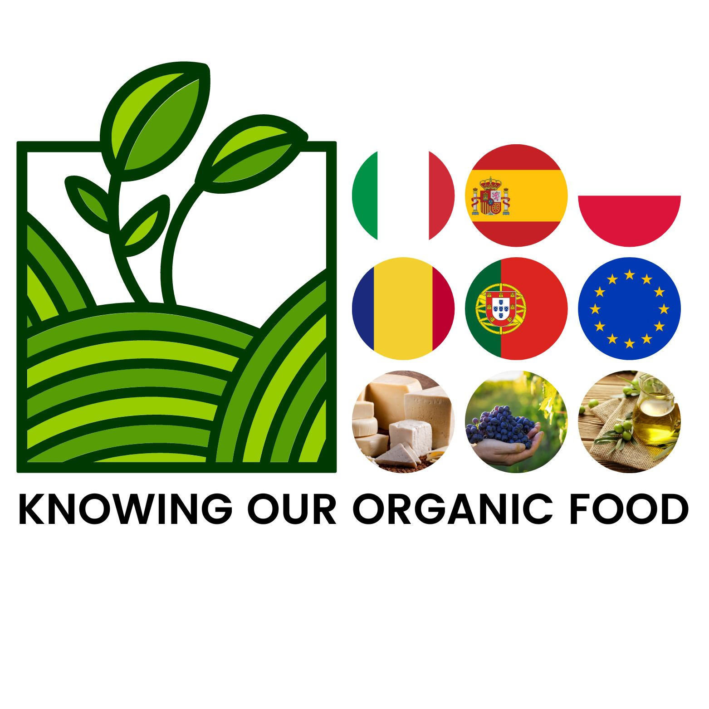
Report on Erasmus activities done in Italy from 22nd to 26th Nov. 2021

On Monday we met for the first time at school at 08:45am and we did a tour to show the school to the foreign students. Later we did a presentation with power point about Italy, Sicily, Canicattì and our school. At 10:30 am we went to a local farm that produces organic food and we interviewed the owner who showed us all the production phases. About 03:30 pm we went to Naro for visiting some Baroque style churches and the famous Chiaramonte castle illustrated by a guide that told us many stories and legends.
On Tuesday morning at 09:00 am we met again at school and we met the president of the "Consorzio isola bio Sicilia", who told us about local organic products and the short supply chain. We then split into groups and went to the supermarket to ask costumers to respond a questionnaire on organic food. Immediately after lunch we gathered at the school to visit Agrigento, in particular the main streets and some churches of the historic center.
On Wednesday at 07:00 am, we met in front of the Belvedere hotel, to go to Palermo. As soon as we arrived in Palermo we visited the Palazzo dei Normanni, to see the “Cappella Palatina” and an art exhibition. Later we went to visit the cathedral of Palermo. After we walked the main streets, and we arrived at the Quattro Canti, the central point of the city. After the lunch break we went to the famous “Teatro Massimo”, designed by the famous architect Ernesto Basile.
On Thursday at 08:45 am we met at school and we attended the lesson given by nutritionist Maria Laura La Vecchia who told us about a healthy diet, the Mediterranean one. Afterwards, we did an interactive questionnaire on the topics presented by the nutritionist.
On Friday, after meeting at school, we left to visit the famous "Valle dei Templi" in Agrigento, which includes several temples: the temple of Juno, the temple of Zeus, the temple of Concordia, the temple of Castor and Pollux.
Finally, in the afternoon we had a "Farewell Party" eating typical local and country food.We danced and sang and enjoyed it a lot.
During the evenings we guys used to get together to socialize and get to know each other better, this also allowed us to improve our English vocabulary.
This experience gave us the opportunity to get to know other people, other cultures and other habits.

December 2021

Italian students’team

