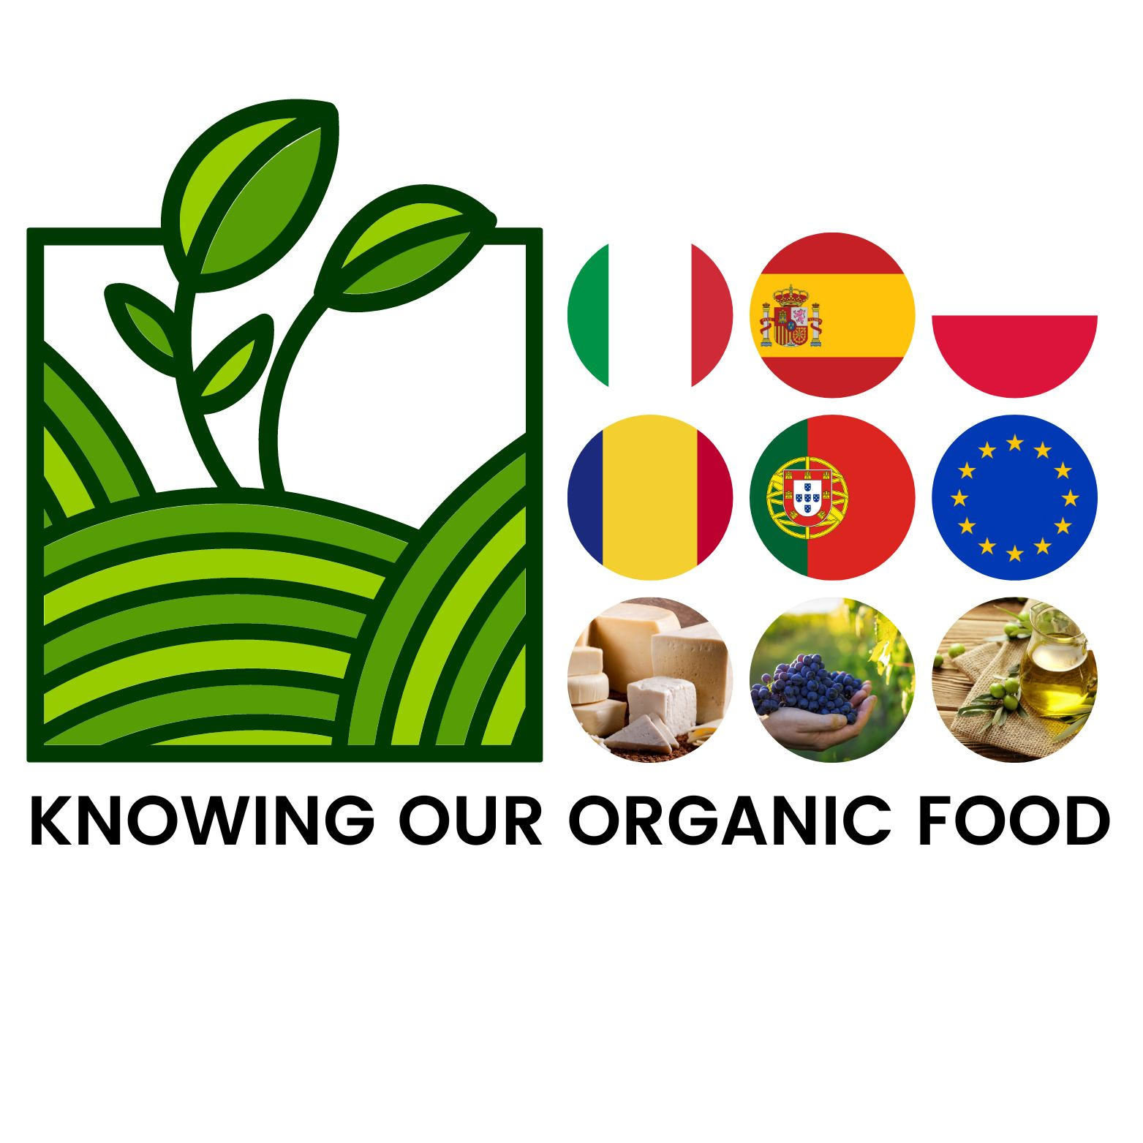ERASMUS PLUS PROJECT “KNOWING OUR ORGANIC FOOD”

ITALIAN STUDENTS’ REPORT ABOUT GUADIX SUPERMARKET SURVEY

Question 1

When asked "why organic food is healthier"

55% of people replied "because it does not contain pesticides"

33% people "because it prevents serious diseases"

And finally 12% replied "because it extends life"

Question 2

To the question "why organic food is more expensive"

22.22% of people replied "because the production process is inferior"

66.66% replied "because they want to make more money"

11.11% "because the production process is greater"

Question 3

"Does organic food contain more nutrients than regular food?"

37.03% of people have "yes"

37.03% have "no"

25.94% have "don't know"

Question 4

When asked "What are some of the most important benefits that organic food can bring to our life and the planet?"

25.92% of people answered "it pollutes the environment less"

55.55% replied "they safeguard animal and floral species"

And 18.51% "no pesticides are used"

Question 5

"For those who live in a city, is there a way to reduce the cost of organic food and still be the healthiest and best option?"

66.66% replied "yes there is"

18.51% "no there isn't"

14.81% "I don't know"

Question 6

What is the difference between organic and non-organic food ?

68 % of people say because “Organic food is healthy”;

32% of people say that “Organic food uses less pesticides”

Question 7

"Is the cost of organic food worth the money?"

37.04% answered "yes"

More than 62.96% answered "no"

Question 8

"Do you know the meaning of carbon footprint?"

44.44% of people replied Alteration of the environment "

Only 3.70% "Environmental innovation"

And 51.85% "Improvement of the environment"

Question 9

"Do you have a government policy that promotes organic food?"

Only 11.11% of people answered "yes we do"

Instead 18.51% answered "no"

And 70.38% "I don't know"

Question 10

"Is organic farming a fashion or a need?"

More than 81.48% think and reply that it is a "fashion"

Instead 18.52% which is "need"
On analysing the answers, we can say that most of people have ,more or less, information about organic food. However, we would like to stress that some replies show people need to know more about it: in question about “organic farming”, for instance, people say that organic farming is a fashion; as regards the question about “carbon footprint” more than 50% don’t know the meaning of it; finally, as for question about nutrients in “Organic food” 50% of people don’t know the right answer. In conclusion we think that governmental institutions, private and public organizations have to give more information on organic food.
April 2022
Asia Lo Giudice, Emanuela Battaglia, Antonio Lupo.

