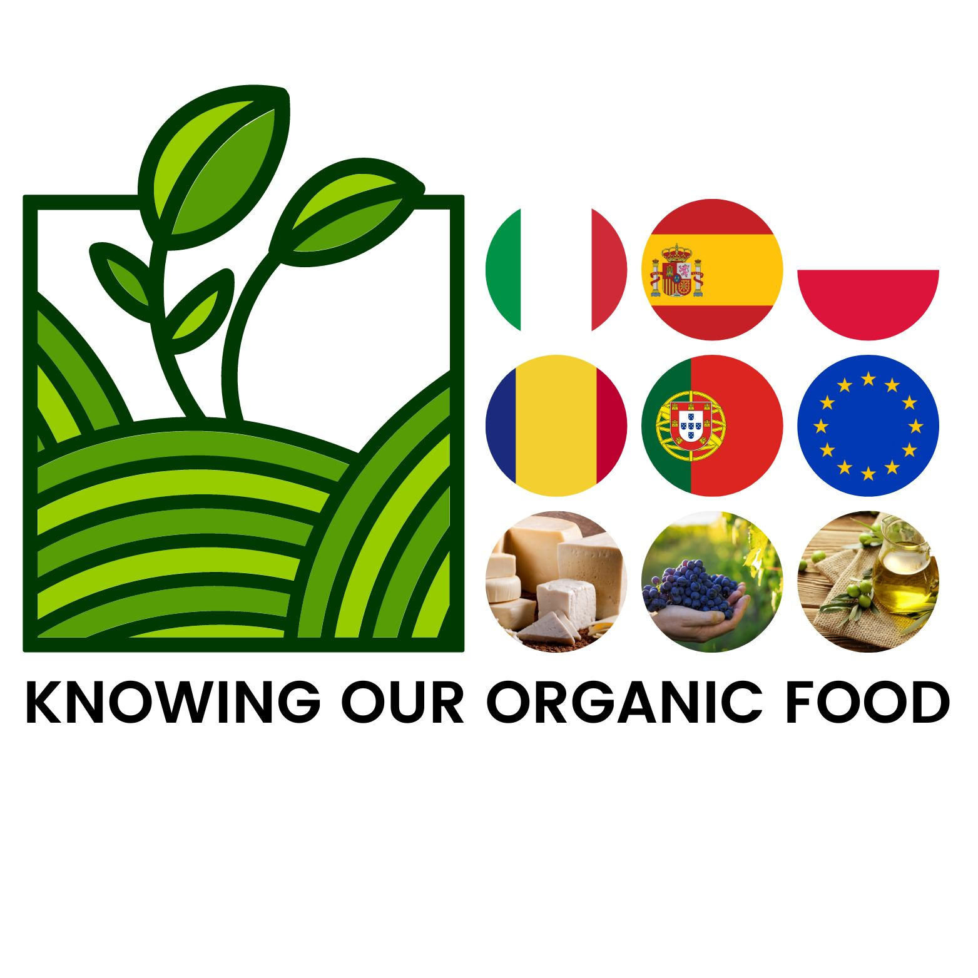

A report from the mobility in Spain -Guadix 21.03-25.03.2022

On 20th March 2022, our Erasmus+ adventure began. On Sunday morning it was time to start exploring Guadix with our teachers and schoolmates. It's a really quaint city full of interesting architecture and amazing places. We took lots of photos and had a lot of fun.In the afternoon, we met our host families and went to our Spanish homes where we got to know all the members of these families and had a nice time with them. March 21st was the first day at Spanish school where we were welcomed by the headmaster, the teaching staff and the students.We learnt a lot of interesting facts about the school, the city and the region we stayed in from presentations given by Spanish students and we had an opportunity to see a live flamenco dance performed by Spanish girls who were dancing in beautiful traditional red dresses and listen to students playing music on different instruments.
Afterwards, all the project participants went to an organic farm where we had a field trip and we were listening to a man who was telling us about this farm and then we tasted delicious local organic food. On the 22nd of March, we took a trip to one of the most beautiful places we have ever seen - the Alhambra. Then we went to the medieval district of Albaicín, where we had some time to eat lunch and relax by walking around the site.On the 23rd of March, the school organized a meeting with a nutritionist, thanks to whom we learned many interesting things, such as facts and myths about being vegan. Afterwards, we had a meeting with the municipality of Guadix, we visited the town hall and the town. An amazing experience was to see old caves where people used to live with all the furniture and equipment. On 24 March, we had an excursion to the Tropolis Heritage Centre, where we baked our own loaves of bread under the guidance and supervision of professional bakers. We also listened to the lecture on making organic goat cheese and created our own ceramic dishes. On the last day of the mobility, we went to a local olive oil factory where we could taste traditionally baked bread with olive oil and tomatoes. Then we listened to the owner who told us about how oil used to be produced and we listened to wonderful music. In the evening it was time to meet our friends and say goodbye. We'll remember this trip for a long time! We hope to meet again soon.

Polish students

