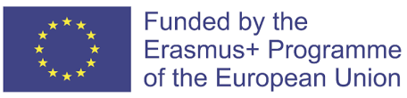
PROJECT COD: 2020-1-IT02-KA229-078973_1
PROJECT TITLE: Knowingourorganicfood

FINAL ASSESSMENT REPORT ON ICT, ENGLISH, ENTREPENEURSHIP AND ORGANIC FOOD SKILLS AND COMPETENCES
In May 2023,Spanish students were administered a final questionnaire about English and ICT skills and competences, as well as entrepeneurship and organic food knowledge in order to know their initial skills and competences and to check their improvement in the above-mentioned educational skills.
The questionnaires administered to students throughout the project and teachers’ reports about them have showed that most participants have achieved the results planned in the application form. Besides, final curricula results confirm these data. We can say that 91% of pupils have got project results. In detail, we can see the percentages of improvement of students who took part in the project below:
- 87% have improved their ICT skills
- 90%have increased their English competences
- 91%have enhanced entrepeneurship competences
- 89%have developed organic food knowledge to a higher level
Date: 05 June 2023
SpanishTeachers:
- Mª Verónica Pérez Rodríguez
- Juan Manuel González Villanueva

