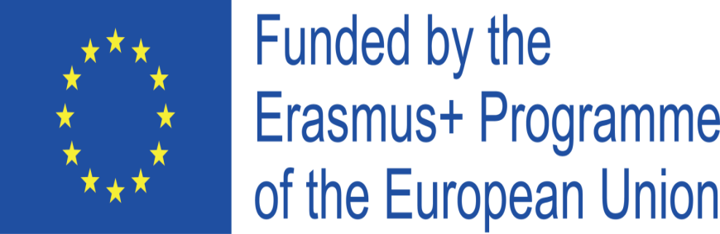
Project Cod.: 2020-1-IT02-KA229-078973_5
Project Title: Knowing our organic food

INITIAL ASSESSMENT REPORT ON ICT, ENGLISH, ENTREPRENEURSHIP AND ORGANIC FOOD SKILLS AND COMPETENCES
By POLISH TEACHERS
At the beginning of October 2020 students have been administered questionnaires on ICT, English, entrepreneurship and organic food in order to know their initial skills and competences and to check their improvement in the above-mentioned educational fields.
ICT questionnaire consists of 10 questions. On analyzing students answers we can say that 32% have poor competences in it, 58% have a medium level and 10% have a good level.
English questionnaire consists of 10 questions to check reading and writing competences and a short audio for assessing listening and speaking skills. Results show that 36% of students involved in the project have poor competences in listening and speaking, whereas 42% have medium competences and 10% have good competences. As for writing and reading competences 18 % reach a good level, 52% reach a medium level and 20% have a poor level.
Entrepreneurship and organic food questionnaire consists of 15 questions. Results stress that 48% of students have poor knowledge in organic food whereas 42% have medium knowledge in it and 10 % have good knowledge in it . As for entrepreneurship competences, results show 24% of students have a poor competences, 48% of students have a medium level ,while 28 % have good competences.

15/10/ 2020
Jolanta Cholewka
Katarzyna Kaptur
Rafał Kowalczyk

