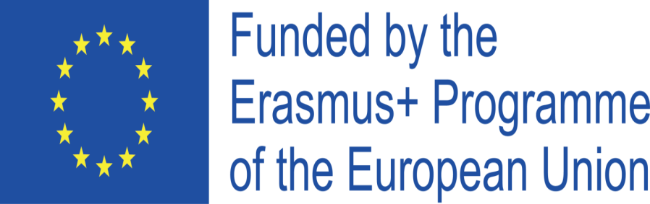
Project Cod.: 2020-1-IT02-KA229-078973_1
Project Title: Knowing our organic food

INTERMEDIATE ASSESSMENT REPORT ON ICT, ENGLISH, ENTREPRENEUR AND ORGANIC FOOD SKILLS AND COMPETENCES
By ITALIAN TEACHERS
In May 2022 students were administered intermediate questionnaires on ICT, English, entrepreneurship and organic food in order to know their intermediate skills and competences and to check their improvement in the above-mentioned educational fields.
English consists of 10 questions and its results showed that 32% of students involved in the project have still a poor competences in listening and speaking, 44% have a medium competences and 24% get a good level . As for writing and reading competences 24 % reached a good level, 64% reached a medium level and 12% had a poor level.
ICT questionnaire consists of 10 questions. On analyzing students answers we can say that 23% have poor competences in it, 65% have a medium level, 12% of students reach a good level of competences.
Entrepreneurship and organic food questionnaire consists of 10 questions and its results stress that 23% of students have poor knowledge in organic food whereas 68% have medium knowledge and 9% reach a good level. As for entrepreneurship competences, results show 11% of students have a poor competences, 61% of students have a medium level ,while 28 % have good competences.
07/06/2022
Italian Teachers

