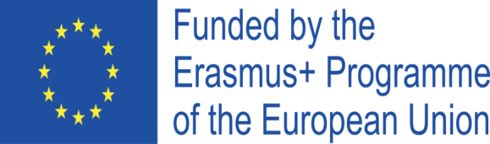
Project Cod.: 2020-1-IT02-KA229-078973_1
Project Title: Knowing our organic food

FINAL ASSESSMENT REPORT ON ICT, ENGLISH, ENTREPRENEURSHIP AND ORGANIC FOOD SKILLS AND COMPETENCES

In May 2023 Romanian students were administered final questionnaire about English and ICT skills and competences, as well as entrepreneurship and organic food knowledge in order to know their initial skills and competences and to check their improvement in the above-mentioned educational fields.
The questionnaires administered to students throughout the project and teachers’ reports about them have showed that most of participants have achieved the results planned in the application form. Besides, final curricula results confirm these data. We can say that 87% of pupils have got projects results. In detail here are the percentages of improvement of students involved in the project:
- 86% have improved their ICT skills;
- 89% have enhanced their English competences;
- 88% have increased entrepreneurship competences;
- 87% have developed organic food knowledge.

Date: 05June2023

Romanian teachers:
Ramona Caragui
Maria Dabelea

